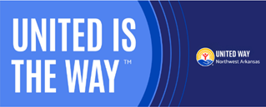

Dear Colleague,

This week we kick off the annual United Way workplace giving campaign at XYZ Company. You will have until XYZ Date to make your pledge to support our goal of raising $XYZ dollars.
Donate today and join us in creating more thriving communities for all. No challenge is too big for us to take on if we work together. Because, United is the Way™ .
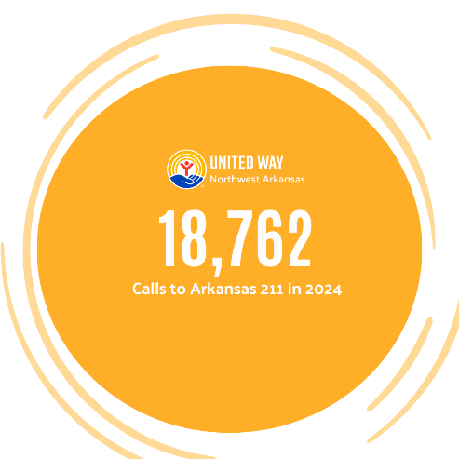
COMMUNITY IMPACT IN 2024
- 7,200+ preschool children in Washington, Benton and Madison counties receive a free book each month in the mail to encourage early learning habits and interest in reading, as part of the Dolly Parton Imagination Library.

- More than 500 customers received utility assistance last year through a new United Way partnership with the Black Hills Cares program.

Giving is convenient; simply click the link to the online form and make your pledge via payroll deduction or with a credit card gift. Insert Link Here.

Sincerely,
COORDINATOR NAME HERE

