Dear Colleague,

This is a reminder message about our workplace giving campaign going on now for United Way of Northwest Arkansas. Gifts to the campaign support programs that help children and families in Benton, Madison, and Washington counties.
Today, so many of our neighbors are working hard to overcome barriers and get ahead. But they’re not alone. Together with community-serving partners and supporters like you, United Way of Northwest Arkansas can connect people to the opportunities they need to reach their full potential and make our community a place where everyone can thrive.
Here are some of the benefits our community has received.
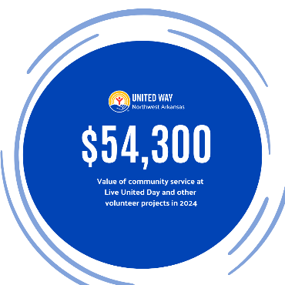
COMMUNITY IMPACT
- 141 families were served through the Joy of Sharing holiday gift program in 2024.

- The PIE program (Partner Impact Empower) will roll out this fall to support our local school districts with supplies that students need to succeed in the classroom and beyond—think traditional supplies, plus items like coats, gloves, socks, and toiletries.

We have raised $XYZ dollar amount so far! Won’t you help us reach our goal? Simply click the link to the online form and make your pledge via payroll deduction or with a credit card gift. You will have until DATE HERE to make your pledge. Insert Link to Form Here.

Sincerely,
COORDINATOR NAME HERE

